

Advanced Data Visualization

Advanced Charts

Geographic Information Systems Charts

73

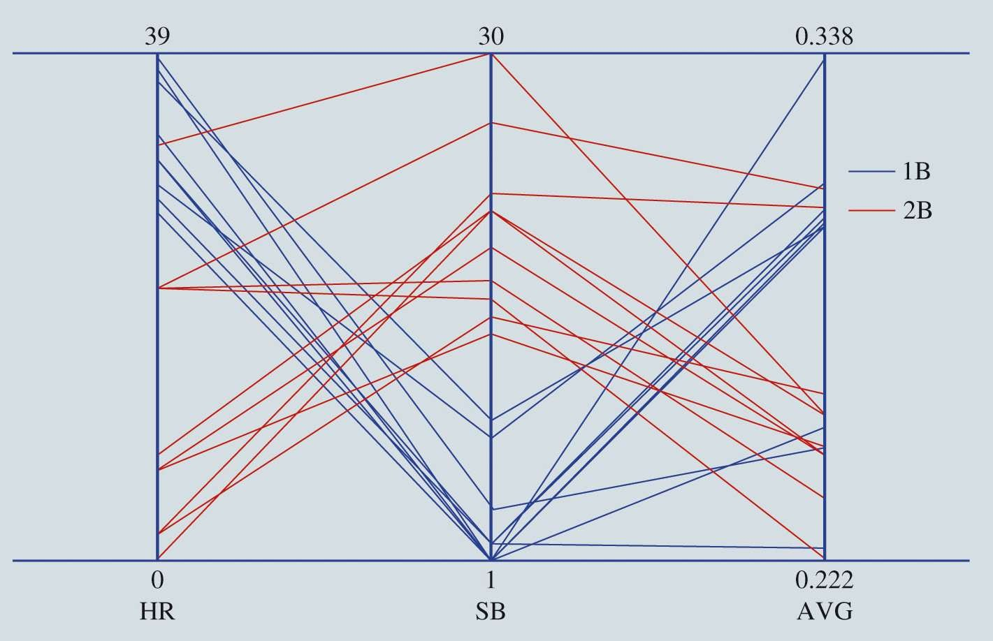

Advanced Data Visualization

Figure 3.33: Parallel-Coordinates Plot for Baseball Data

* **Parallel-coordinates plot**: Chart for examining data with more than two variables:
  + Includes a different vertical axis for each variable.
  + Each observation is represented by drawing a line on the parallel- coordinates plot connecting each vertical axis.
  + The height of the line on each vertical axis represents the value taken by that observation for the variable corresponding to the vertical axis.

74



Advanced Data Visualization

Figure 3.34: SmartMoney’s Map of the Market as an Example of a Treemap

* **Treemap**:
  + Useful for visualizing hierarchical data along multiple dimensions.
* Each rectangle represents a particular company
* Color of the rectangle represents the overall performance
* The size provides information on the company’s market capitalization size
* Useful to quickly get an idea of the performance of individual companies relative to other companies

75

Figure 3.36: GIS Chart for Cincinnati Zoo Member Data

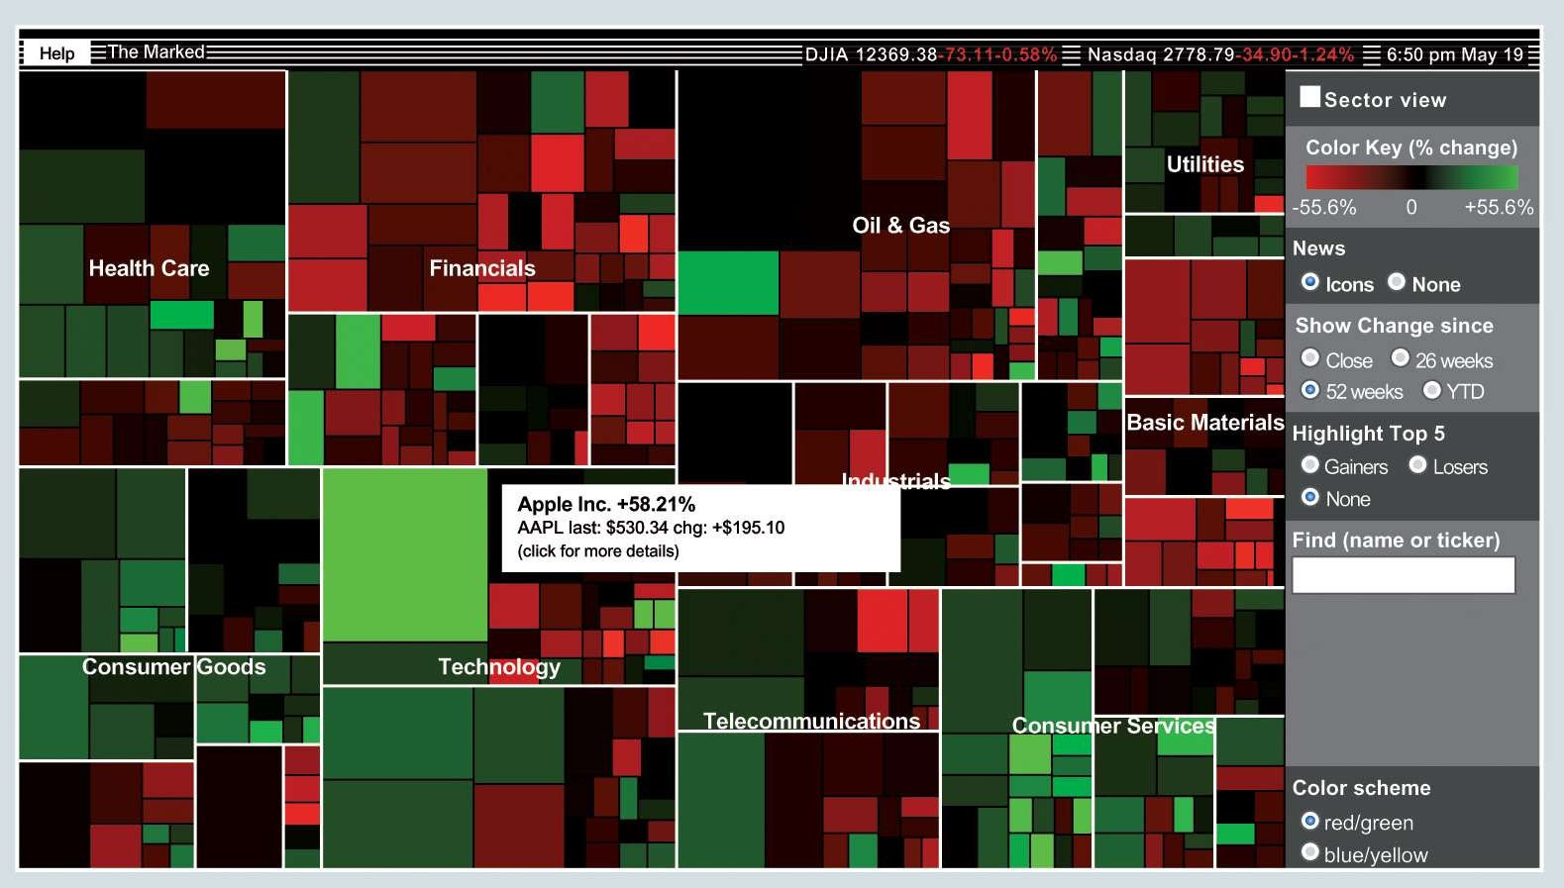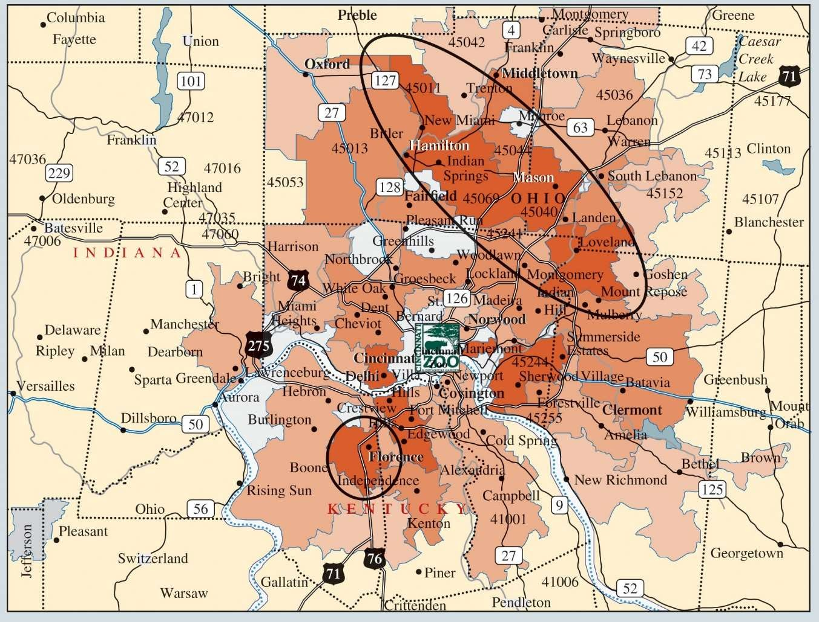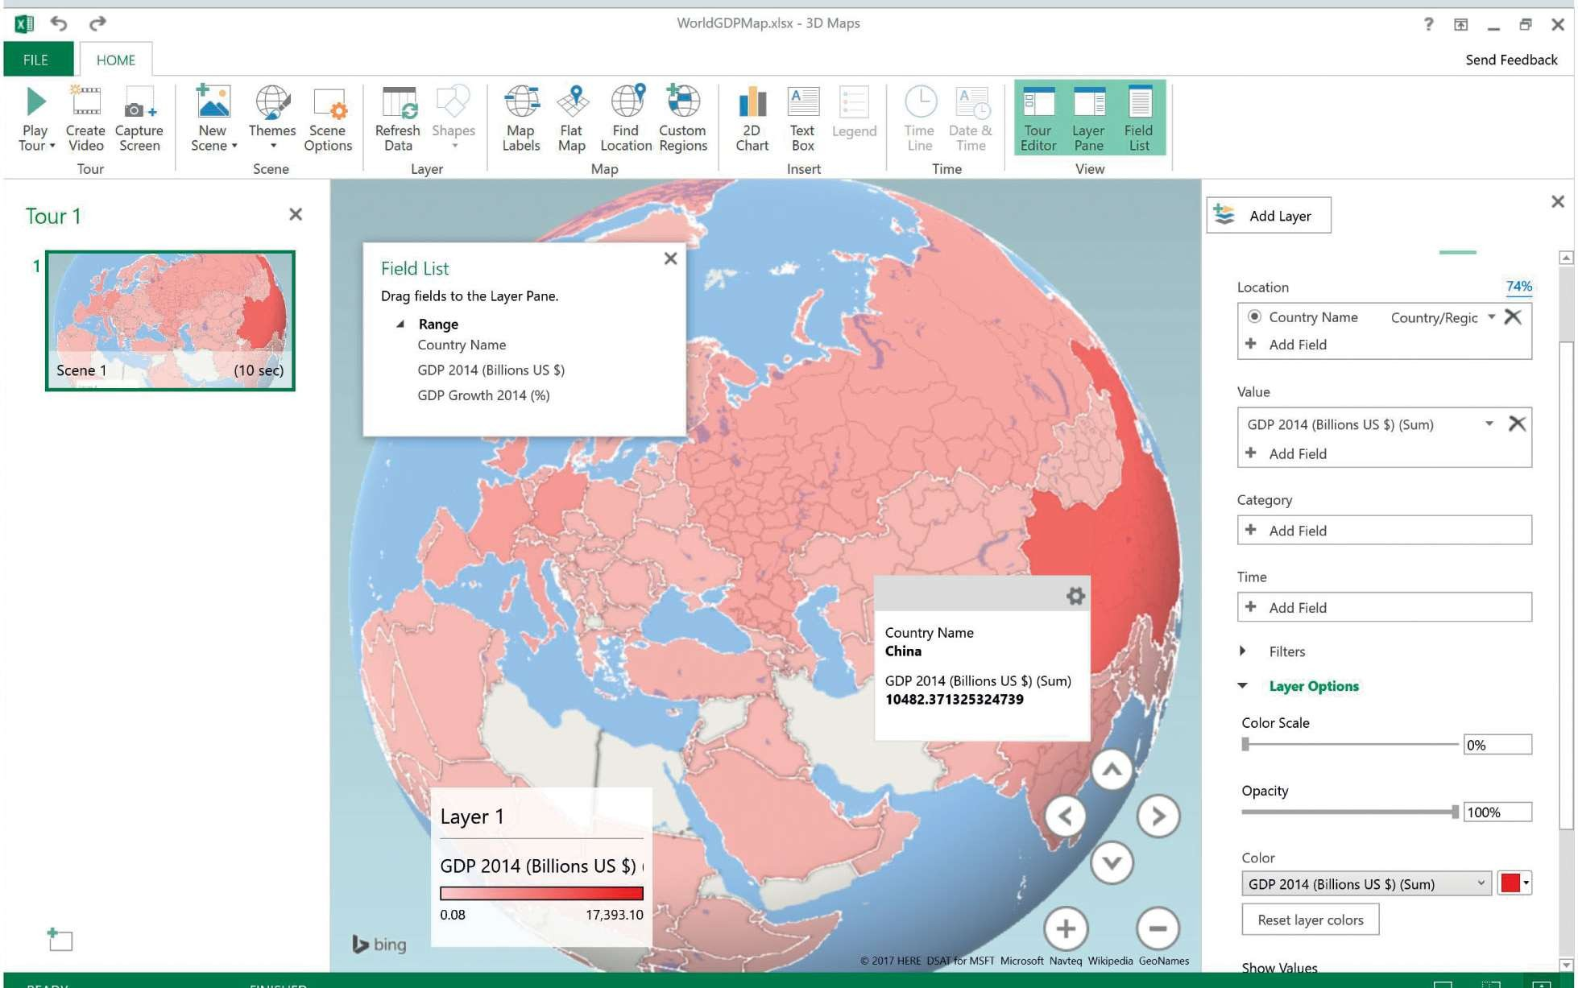

Advanced Data Visualization

* Geographic Information Systems Charts: (Maps)
  + Geographic information system (GIS):
    - A system that merges maps and statistics to present data collected over different geographic areas.
  + Helps in interpreting data and observing patterns.

76



Data Dashboards

Principles of Effective Data Dashboards Applications of Data Dashboards

77



# Data Dashboards

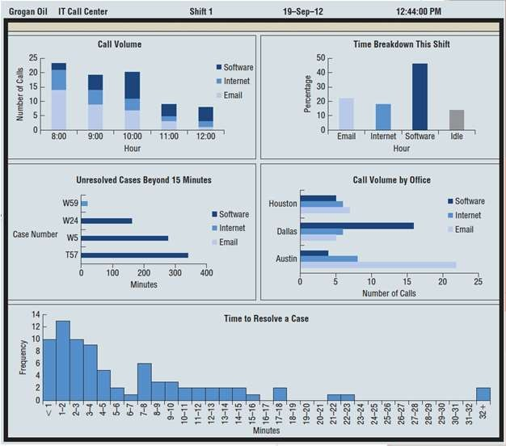

* **Data dashboard**:
  + Data-visualization tool that illustrates multiple metrics and automatically updates these metrics as new data become available.

## Example: Grogan’s IT call center

* + Dashboard developed to monitor the performance of the call center
  + Different charts to track:
    - Call Volume
    - Percent of Time solving problems
    - Call Volume by problem for locations
    - Time of unresolved problems

Figure 3.39: Data Dashboard for the Grogan Oil Information Technology Call Center

78



Principles of Effective Data Dashboards:

* **Key performance indicators (KPIs)** in dashboards:
  + Automobile dashboard: Current speed, Fuel level, and oil pressure.
  + Business dashboard: Financial position, inventory on hand, customer service metrics.

79

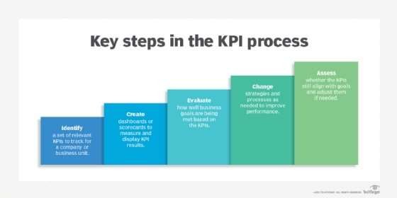

# Principles of Effective Data Dashboards:



Principles Continued:

* Should provide timely summary information on KPIs that are important to the user.
* Should present all KPIs as a single screen that a user can quickly scan to understand the business’s current state of operations.
* The KPIs displayed in the data dashboard should convey meaning to its user and be related to the decisions the user makes.
* A data dashboard should call attention to unusual measures that may require attention.
* Color should be used to call attention to specific values to differentiate categorical variables, but the use of color should be restrained.

80



Advanced Data Visualization in Excel

Figure 3.35: Treemap Created in Excel for Top 100 Global Companies Data

81

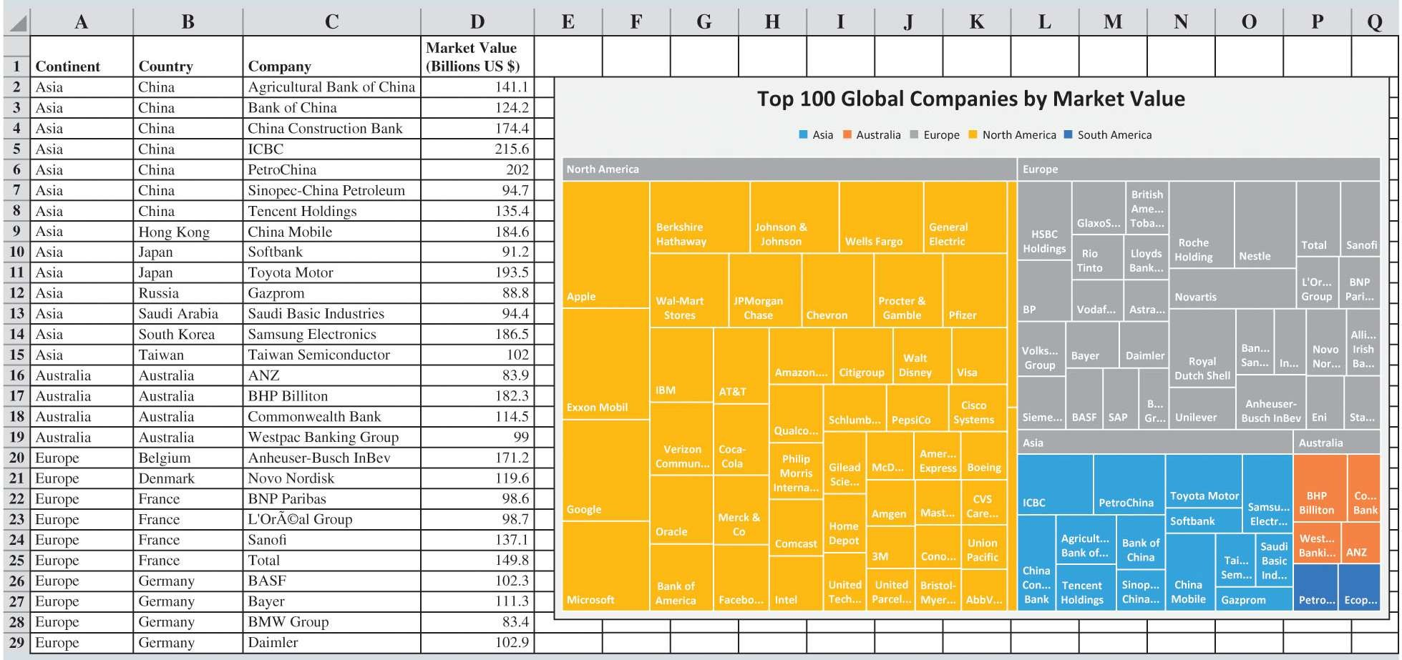

Advanced Data Visualization in Excel

82